User Manual - Virtual Vending Machine Web App

Introduction
This guide explains how to use the Virtual Vending Machine Web App, covering everything from selecting items to making payments and viewing receipts. The system is designed to provide a smooth and intuitive vending experience with automatic stock management and real-time payment processing.

1. Accessing the Web App
To access the vending machine system, open your browser and enter the following URL:
http://localhost:8080

This will take you to the Following Home Page:
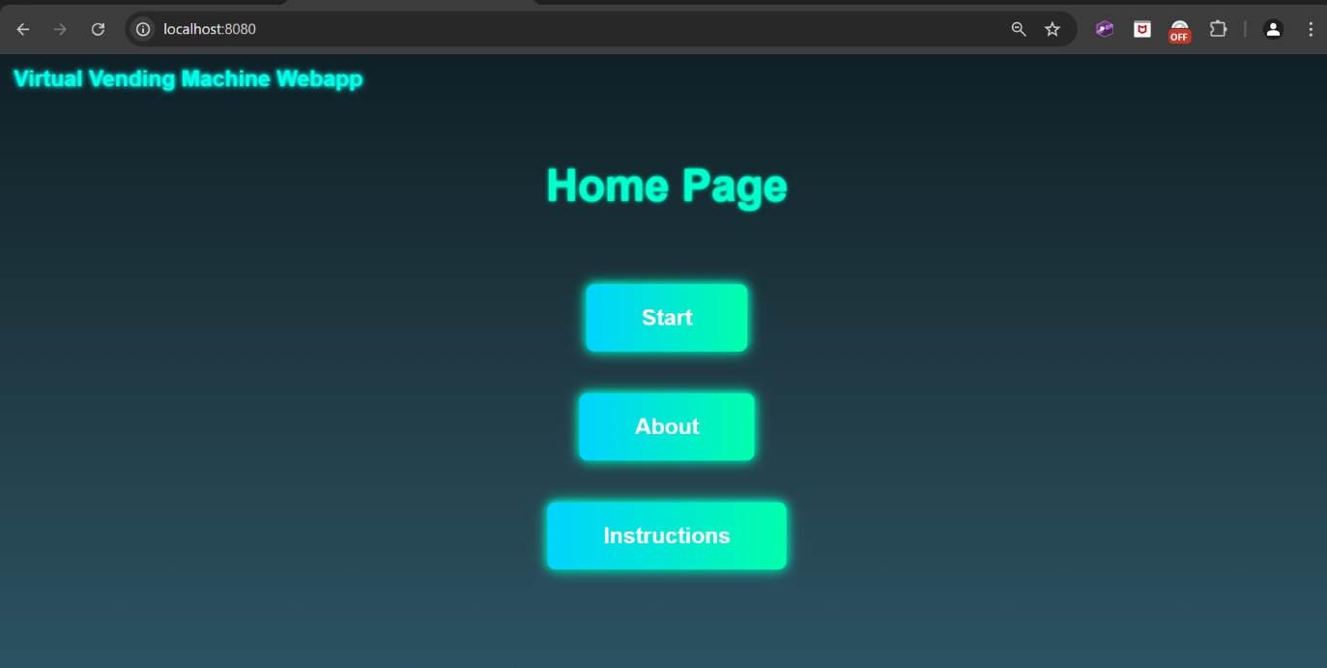

2. Navigation
Select one of the three buttons to choose what to do next. The About button takes you to a page with general information about the system. The instructions button will take you to a page where you can view an interactive version of this exact User Manual in case you need quick access to it. Finally, the Start button will take you to the main page for using the Vending Machine.

3. Using the Machine
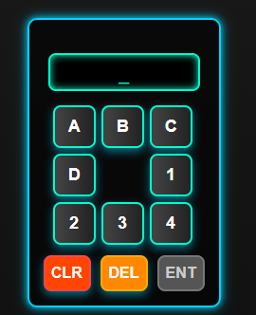
When on the main page you are free to explore the products on offer inside the Vending Machine. Your Cart is displayed on the right side of the machine and there are instructions for using the machine on the left side of the page. When you are ready to start purchasing items, you can use the Keypad to add items to your cart:
Enter the relevant Item Code of the Items you want, using the Keypad keys. When a valid code has been entered, the ENT button will become active. Press this button or ENTER on your keyboard to add the chosen item to your cart. If you enter the wrong code, you can use the DEL button, or BACKSPACE/DELETE on your keyboard to delete the last character in the display. Additionally, to clear the entire Keypad display, click the CLR button.
WARNING: The Keypad has been programmed to only accept a Letter entry followed by a Number entry; to help ensure you enter a valid Item code.

4. Cart Management
The cart is always visible on the page, displaying all selected items in real time. For each Item it displays the: Item Name, Item Code, Quantity and Price. It also displays the Total Cost of all Items in the Cart. All these automatically update with changes, e.g. the Total Price will dynamically increase/decrease when items are added/removed from the cart respectively.

Within the Cart, you can:
  - See the Total Cost of all selected products.
  - Remove an item from the Cart by clicking the “X” button next to it.
  - Increase an Item’s Quantity by clicking the “+” button next to it.
  - Decrease an Item’s Quantity by clicking the “-” button next to it.
  - Clear the cart entirely before proceeding to payment by clicking the “Clear Cart” button at the bottom of the Cart.
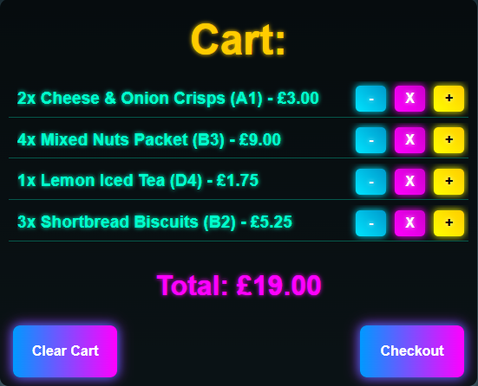
WARNING: If you are trying to increase the Quantity of an Item to more than is available, an alert may appear at the top of the page, informing you that there is insufficient stock and you can’t add anymore to your Cart.

When you are happy with your Cart, and ready to pay, simply click the “Checkout” button to proceed to the Payment stage

5. Making a Payment
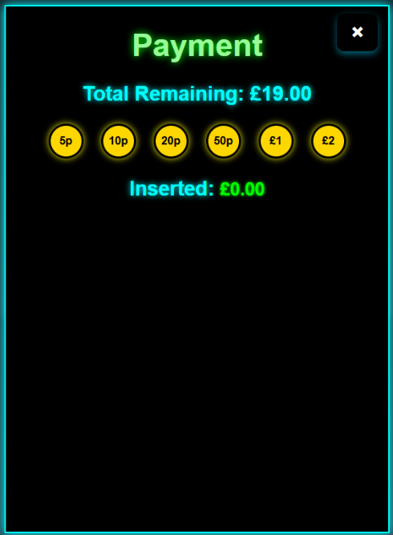
Once you enter the Checkout stage, your Cart will disappear and be replaced by the payment display:

You are then free to use the coin buttons to make your payment. The system will track the amount inserted in real-time and automatically update the Total Remaining and Inserted amount as you enter coins.
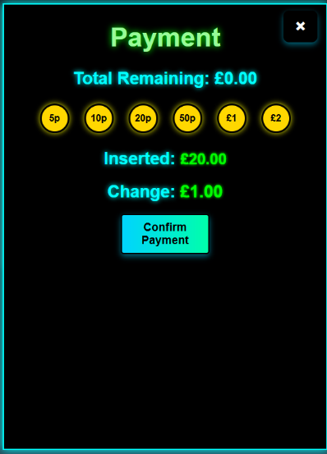
Once the payment matches or exceeds the total cost, the “Confirm Payment” button will become visible along with your change amount (if any):

These will not appear until a sufficient payment has been made. When you are ready to pay, click the “Confirm Payment” button. You will be asked for confirmation through a popup alert and to complete the payment press ok.
This will display a popup on the screen confirming your payment and showing your items:
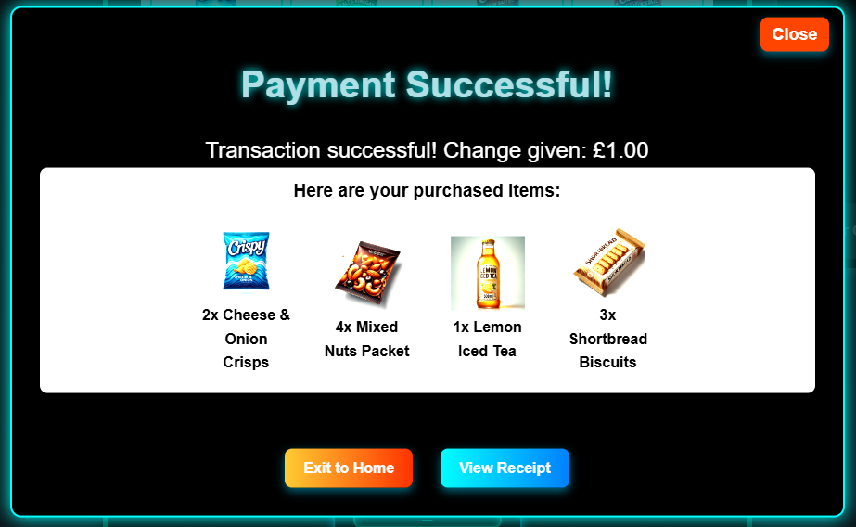

You may view this for as long as you require. When you are finished, if you wish to use the machine again immediately, press the “Close” button to remove the popup and the Vending Machine will be reset for you to use again. If you wish to exit to the Home Page instead, press the “Exit to Home” button. If you wish to claim your receipt first, see the next section.

6. Viewing Your Receipt
- After a successful transaction, the system generates a Transaction ID.
- If you wish to view your receipt: Click "View Receipt", or manually enter the transaction ID at: http://localhost:8080/receipts/{transactionID}
- The receipt includes:
  - Transaction details (ID, date, time).
  - Items purchased (name, quantity, price per unit, and total price).
  - Total Cost, Payment Received, and Change Given.

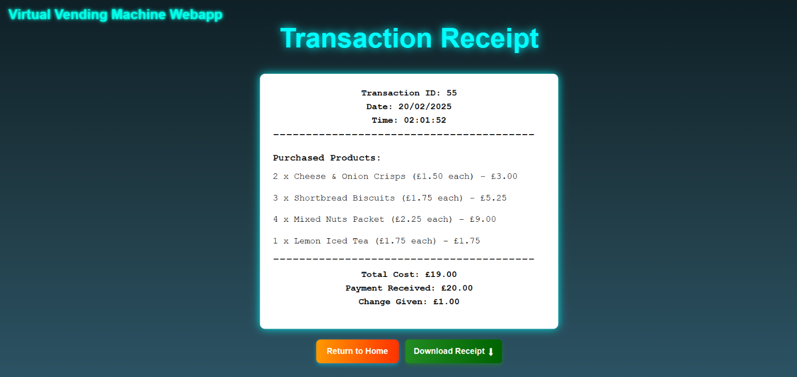

7. Downloading Your Receipt
If you are happy to view it then leave, click “Return to Home” when ready. If you wish to download a copy of the receipt, Click the "Download Receipt" button.
The receipt is downloaded as a .txt file, formatted exactly like the on-screen receipt.
The filename follows this format:
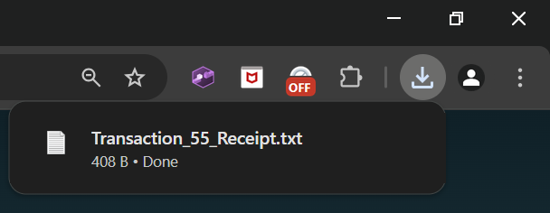
Receipt_{TransactionID}.txt

Open the file to view or print it.

8. Automatic Stock Updates & Alerts
If a product’s stock falls below 5 after the transaction, the system automatically restocks it by 10 units.
A notification will appear saying:
Low stock for {Product Name(s)} has been detected and auto-restocked!
This ensures that frequently purchased items always remain available.
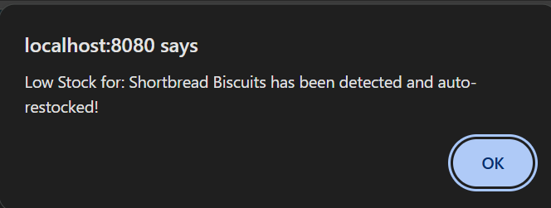
The notification is logged in the console and immediately appears as an alert on the screen after a payment has been completed.

9. Troubleshooting & Common Issues

Issue | Possible Cause | Solution
Payment not processing | Not enough coins inserted | Continue clicking coin buttons until the total cost is covered.
Receipt not found | Incorrect transaction ID entered | Double-check the transaction ID and try again.
Wrong item added | Incorrect item code entered | Clear the cart and re-enter the correct item code.
Restock alert not showing | Stock hasn't dropped below the threshold | This feature triggers only when stock falls below the threshold (currently set at 5).

10. Future Enhancements
Upcoming updates may include:
- Email receipts for completed transactions.
- A login system to allow querying previously saved transactions
- More advanced auto-restocking settings.
- Wider range of Items and Categories.
- Product Recommendations

11. Contact & Support
For any issues, queries or support requests, reach out to the development team:
CREATOR: Issa Aboobaker, ia252@student.le.ac.uk.

